Chapter 3 Physical Properties and Intermolecular Forces name: class:
1. 掌握物质三态的特征与区别（考点A: 物质三态 Three States of Matter）
Solid: particles in fixed positions, vibrate only; definite shape and volume
Liquid: particles close together but can move past each other; definite volume, no definite shape
Gas: particles far apart, move freely in all directions; no definite shape or volume; highly compressible
Crystalline solid: orderly, repeating atomic structure; Amorphous solid: disordered, non-repeating structure
Solids and liquids have similar molar volumes; gases have much larger molar volume and are easily compressed

1. Which of the following best explains why liquids have a definite volume but no definite shape? （ ）
A. The particles in a liquid are in fixed positions and can only vibrate.
B. The particles in a liquid are loosely packed and can move past each other, but are still close together.
C. The particles in a liquid are spread out and move freely in all directions.
D. The particles in a liquid are tightly packed and cannot move.

2. Which of the following statements explains why gases are highly compressible compared to solids and liquids? （ ）
A. Gases are composed of particles that are in constant random motion, which prevents them from having a fixed shape.
B. The particles in a gas have very little intermolecular force, allowing them to move freely.
C. Gases are highly compressible because the particles are widely spaced, leaving large amounts of empty space between them.
D. The pressure of a gas is determined by the frequency and force with which particles strike the walls of their container.

3. Which of the following best describes the difference between crystalline and amorphous solids? （ ）
A. Crystalline solids are composed of molecules in fixed positions, while amorphous solids allow molecules to flow freely.
B. Crystalline solids have an orderly, repeating atomic structure, while amorphous solids have a disordered, non-repeating structure.
C. Amorphous solids are more compressible than crystalline solids due to their disordered structure.
D. Crystalline solids are typically formed when liquids cool quickly, while amorphous solids are formed when liquids cool slowly.

2. 掌握相变与蒸气压（考点B: 相变 Phase Change）
Melting/boiling points are positively correlated with the strength of intermolecular forces
Vapor pressure is inversely related to boiling point: stronger IMF -> lower vapor pressure -> higher boiling point
When comparing substances with similar molar masses, stronger IMF leads to higher melting/boiling points

1. The correct order of increasing boiling points for the following compounds is （ ）
A. 1-chlorobutane (CH₃CH₂CH₂CH₂Cl) < butane (C₄H₁₀) < butan⁻¹-ol (CH₃CH₂CH₂CHOH)
B. butan⁻¹-ol (CH₃CH₂CH₂CHOH) < 1-chlorobutane (CH₃CH₂CH₂CH₂Cl) < butane (C₄H₁₀)
C. butane (C₄H₁₀) < 1-chlorobutane (CH₃CH₂CH₂CH₂Cl) < butan⁻¹-ol (CH₃CH₂CH₂CHOH)
D. butan⁻¹-ol (CH₃CH₂CH₂CHOH) < butane (C₄H₁₀) < 1-chlorobutane (CH₃CH₂CH₂CH₂Cl)

2. Which isomer of pentane shown above has the highest boiling point and why? （ ）
A. 2,2-dimethylpropane because it can exhibit dipole-dipole forces.
B. Pentane because it is less compact than 2,2-dimethylpropane.
C. 2,2-dimethylpropane because its molecules are more polarizable.
D. 2,2-dimethylpropane because it has a greater molar mass than pentane.

3. MoleculeBoiling Point °CCH₃CH₂CHF₂-42CH₃CH₂CHCl₂₃₅CH₃CH₂CHBr₂₇₃ Which of the following statements is correct? （ ）
A. The strongest type of intermolecular force in CH₃CH₂CHF₂ is hydrogen bonding.
B. London dispersion forces account for the difference in boiling point.
C. The dipole-dipole interactions between CH₃CH₂CHBr₂ are stronger than the dipole-dipole interactions between CH₃CH₂CHCl₂.
D. The molecules only interact through London dispersion forces.

4. Different substances have characteristic melting and boiling points, depending on the strength of the bonds or forces holding them together.
Which explains why methane has a lower melting point than sodium chloride? （ ）
A. Covalent bonds are weaker than ionic bonds.
B. Intermolecular forces are weaker than ionic bonds.
C. Covalent bonds are stronger than ionic bonds.
D. Intermolecular forces are stronger than ionic bonds.

5. Which of the following factors is primarily responsible for the increase in melting points observed as you move down Group 7A from fluorine to astatine? （ ）
A. Atomic mass increases.
B. Intermolecular forces become stronger.
C. The size of the molecules decreases.
D. The atomic number decreases.

6. Molar mass (g mol-1)Vapor pressure at 20 oC (mm Hg)CBr₄₃₃1.60.8CCl₄₁₅3.8115.0 Based on the information in the table above, which of the following best explains why CCl₄ has a higher vapor pressure that CBr₄? （ ）
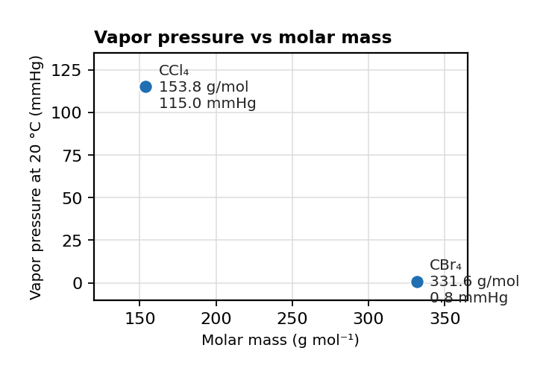
图 C₀3-1：蒸气压 vs 摩尔质量散点图（对应第 2 考点 MCQ6，CBr₄ 与 CCl₄）
A. CCl₄ has stronger dipole-dipole forces that CBr₄.
B. CCl₄ has weaker dipole-dipole forces that CBr₄.
C. CCl₄ has stronger London dispersion forces that CBr₄.
D. CCl₄ has weaker London dispersion forces that CBr₄.

7. Two molecular substances, A and B, have similar molar masses.
Substance A has hydrogen bonding between its molecules, while substance B is nonpolar with only London dispersion forces.
Which statement correctly predicts their relative boiling points? （ ）
A. A has a lower boiling point because hydrogen bonding breaks more easily than London forces.
B. B has a higher boiling point because nonpolar molecules can pack more efficiently, increasing intermolecular forces.
C. A has a higher boiling point due to stronger intermolecular forces from hydrogen bonding.
D. A and B have identical boiling points since they have similar molar masses.

3. 掌握分子间作用力（IMF）的类型并能据此比较物理性质（考点C: 分子间作用力 Intermolecular Forces）
London dispersion forces (色散力): present in ALL molecules; strength increases with more electrons (larger, more polarizable)
Dipole-dipole forces (偶极-偶极力): present in polar molecules
Hydrogen bonding (氢键): especially strong dipole-dipole force; occurs when H is bonded to N, O, or F
Relative strength: H-bond > dipole-dipole > London dispersion

1. Which correctly orders the boiling points of CH₄, CH₃F, and CH₃OH from lowest to highest? （ ）
A CH₄ < CH₃F < CH₃OH
B CH₃OH < CH₃F < CH₄
C CH₃F < CH₄ < CH₃OH
D CH₄ < CH₃OH < CH₃F

2. NH₃ has a much higher boiling point (-33 degrees C) than PH₃ (-88 degrees C) despite PH₃ having greater molar mass.
This is because: （ ）
A NH₃ has stronger London dispersion forces.
B NH₃ exhibits hydrogen bonding while PH₃ does not.
C PH₃ is a larger molecule.
D NH₃ has a smaller bond angle.

3. CCl₄ and CF₄ are both nonpolar. Which has the higher boiling point and why? （ ）
A CF₄ because it is more polarizable.
B CCl₄ because it has more electrons and stronger London forces.
C Both have the same boiling point.
D CF₄ because it has stronger C-F bonds.

4. For each pair, identify all types of IMF and predict which has the higher boiling point:
(a) CH₃OCH₃ (dimethyl ether) and CH₃CH₂OH (ethanol). Justify. [2 marks]
(b) Ar and HCl. Justify. [2 marks]

5. Iodine, I₂, is more soluble in CCl₄ than in water. Explain in terms of intermolecular forces. （ ）
(a) Explain why I₂ dissolves better in CCl₄ than in water. [2 marks]

6. What is the strongest type of intermolecular force exhibited in the amino acid molecule serine? （ ）
A. permanent dipole-dipole forces
B. London dispersion forces
C. Option C
D. Option D

7. For the dissolution of an ionic compound to be exothermic, the energy released by the ion-dipole interactions in solution must be greater than which of the following? （ ）
A. The energy required to overcome hydrogen bonding between water molecules
B. The strength of the ionic bonds in the solid lattice
C. The covalent bond strength within the water molecules
D. The kinetic energy of the dissociated ions in solution

8. Which of the following statements about propanone and propanal are correct? （ ）
I. The strongest type of intermolecular force in both molecules is hydrogen bonding
II. The strongest type of intermolecular force in both molecules is permanent dipole permanent dipole forces
III. Both compounds are soluble in water
A. Option A
B. Option B
C. Option C
D. Option D

9. Which of the cations is most likely to have the weakest attraction to an adjacent water molecule in solution? （ ）
A. Option A
B. Option B
C. Option C
D. Option D

10. Which of the following is a nonpolar molecule containing polar bonds? （ ）
A. Option A
B. Option B
C. Option C
D. Option D

11. Which of the following is not a correct representation of hydrogen bonding? （ ）
A. Two water molecules with H of one attracted to O of another (correct H-bond)
B. Two water molecules with O–O direct attraction
C. A water molecule with H atoms attracting each other
D. Two water molecules with H of one repelling O of another

12. Which of the following compounds does not form hydrogen bonds? （ ）
A. Option A
B. Option B
C. Option C
D. Option D

13. What is the primary reason why lipids are insoluble in water? （ ）
A. Lipids have polar tails that cannot form hydrogen bonds with water molecules
B. Lipids are nonpolar and do not form hydrogen bonds with water molecules
C. Lipids form strong covalent bonds with themselves, preventing water solubility
D. Lipids form ion-dipole interactions that weaken their solubility

14. The diagram above represents a particle in aqueous solution.
Which of the following statements about the particle is correct? （ ）
A. The particle is an anion.
B. The particle does not have a charge.
C. The particle is a cation.
D. Water is a nonpolar molecule, so the charge of the particle cannot be determined.

15. Which of the following compounds will not form hydrogen bonds? （ ）
A. Option A
B. Option B
C. Option C
D. Option D

16. Which of the following molecules will have the weakest dipole-dipole interactions? （ ）
A. Option A
B. Option B
C. Option C
D. Option D

17. The structure of cellulose is shown above.
Cellulose is a polymer that is insoluble in water, but it is made from water soluble glucose monomers.
Which of the following types of noncovalent interactions is most likely responsible for the structure and insolubility of cellulose in water? （ ）
A. Option A
B. Electrostatic/Ionic interactions.
C. Hydrophobic interactions.
D. Van der Waals interactions.

4. 掌握固体类型（离子、金属、分子、共价网络）及其性质（考点D: 固体类型与性质 Types of Solids）
Ionic solids: high mp, conductive when molten/dissolved, brittle (e.g. NaCl, KBr)
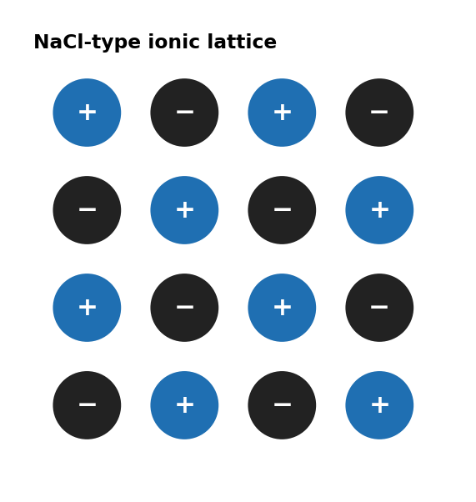
图 C₀3-3：NaCl 型离子晶格示意（对应第 4 考点）
Metallic solids: variable mp, conductive, malleable (e.g. Cu, Fe)
Molecular solids: low mp, non-conductive, soft (e.g. I₂, C10H₈)
Covalent network solids: very high mp, non-conductive, very hard (e.g. diamond, SiO₂)
Substitutional alloy (置换合金): atoms have similar radii, one replaces the other (e.g. brass: Cu/Zn)
Interstitial alloy (间隙合金): smaller atoms fit in spaces between larger atoms (e.g. steel: Fe/C)

1. Which type of solid does SiO₂ (quartz) form? （ ）
A ionic
B metallic
C molecular
D covalent network

2. Graphite conducts electricity while diamond does not. This is because: （ ）
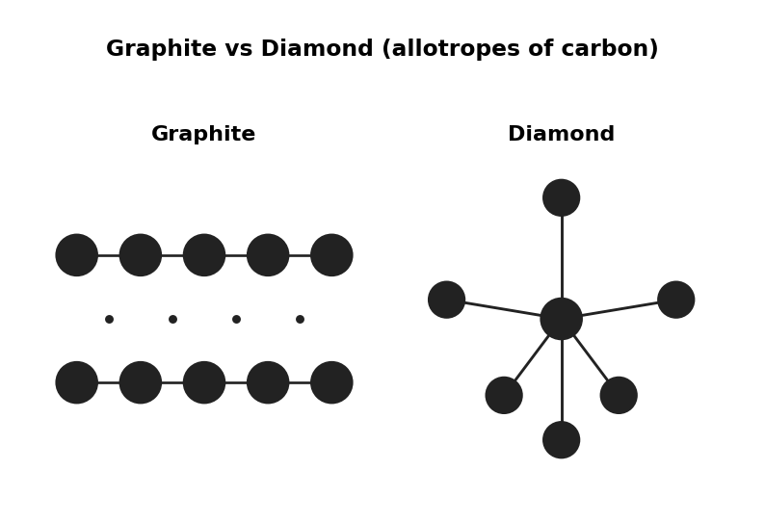
图 C₀3-4：石墨与金刚石结构示意（对应第 4 考点 MCQ2）
A graphite is an ionic solid.
B graphite has delocalized electrons between layers; diamond has all electrons localized in bonds.
C diamond has stronger covalent bonds.
D graphite is a metallic solid.

3. Classify each solid and describe one characteristic property:
(a) KBr [2 marks]
(b) C10H₈ (naphthalene) [2 marks]

4. Sterling silver is an alloy of Ag (144 pm) and Cu (128 pm). This is a: （ ）
A substitutional alloy because atoms have similar radii.
B interstitial alloy because Cu is smaller.
C covalent network solid.
D ionic compound.

5. A 15.0 g sterling silver ring contains 92.5% Ag by mass. （ ）
(a) Calculate the mass of copper in the ring. [1 mark]

6. The diagrams below are various models of metallic bonding. Which models represent pure metals? （ ）
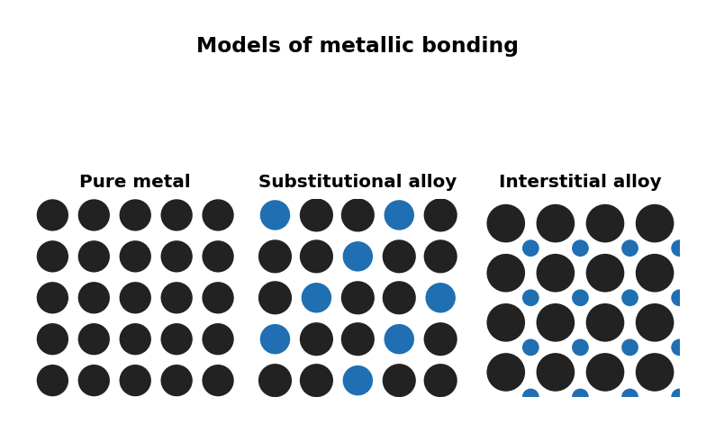
图 C₀3-2：金属键模型示意（对应第 4 考点 MCQ6–8，纯金属/取代合金/间隙合金）
A. Diagram A — particle arrangement
B. Diagram B — particle arrangement
C. Diagram C — particle arrangement
D. Diagram D — particle arrangement

7. The diagrams below are various models of metallic bonding.
Which model represents a substitutional alloy, such as brass? （ ）
A. Diagram A — particle arrangement
B. Diagram B — particle arrangement
C. Diagram C — particle arrangement
D. Diagram D — particle arrangement

8. The diagrams below are various models of metallic bonding.
Which model represents an alloy that is less malleable, harder and has a higher melting point? （ ）
A. Diagram A — particle arrangement
B. Option B
C. Option C
D. Option D

9. Which of the following statements explains why ionic solids tend to have high melting points? （ ）
A. The particles in ionic solids are small and vibrate easily.
B. The ions in the solid are arranged in a way that maximizes repulsion, leading to strong forces.
C. Ionic solids contain delocalized electrons that conduct heat.
D. Strong electrostatic forces between oppositely charged ions in a 3-D lattice require significant energy to overcome.

10. Which of the following conditions must be true for a substitutional alloy to form? （ ）
A. The two metals must have different atomic radii.
B. The two metals must have significantly different electronegativities.
C. The two metals must have similar atomic radii and chemical properties.
D. The two metals must be in the same group of the periodic table.

11. Which of the following elements is most likely to form an interstitial alloy with iron? （ ）
A. Option A
B. Option B
C. Option C
D. Option D

12. Which of the following statements explains why the interstitial alloy steel has different properties to pure iron? （ ）
A. Carbon atoms increase the density of the iron lattice.
B. Carbon atoms weaken the Coulombic forces in the lattice.
C. Carbon atoms occupy the spaces between iron atoms, strengthening the lattice.
D. Carbon atoms substitute for iron atoms, maintaining uniformity.

13. Considering the structure of ionic crystals, which of the following is incorrect? （ ）
A. The systematic arrangement maximizes the Coulombic forces of attraction between positive ions and the sea of delocalized electrons.
B. The systematic arrangement minimizes the Coulombic forces of repulsion between equally charged ions.
C. Ions are arranged in a close packed regular lattice of alternating charged ions.
D. The strength of the Coulombic forces between the ions is proportional to the magnitude of the charge of the ions.

14. Piano strings are made from an alloy of iron and carbon, with a small amount of manganese, known as spring steel.
The resulting steel-manganese alloy has an especially high tensile strength, allowing it to withstand high amounts of tension without breaking.
Which of the following diagrams best represents the structure of spring steel? （ ）
A. A simple molecular lattice with weak intermolecular forces between small molecules
B. Option B
C. Option C
D. Option D

15. Which combination of factors would most significantly increase the melting point of an ionic crystal? （ ）
A. Decreased ion charge and increased ionic radius
B. Increased ion charge and decreased ionic radius
C. Uniform ion sizes and minimal charge differences
D. Maximized lattice symmetry without charge considerations

16. Which of the following statements explains why substitutional alloys like brass are malleable? （ ）
A. Substitutional alloys have free-moving delocalized electrons.
B. Substituting atoms prevent dislocation movement in the lattice.
C. Atoms in substitutional alloys are held together by weak van der Waals forces.
D. Substituting atoms maintain the metallic bonding’s sea of electrons.

17. Which of the following statements about diamond and graphite is correct? （ ）
A. The carbon atoms are joined together by three covalent bonds.
B. They both conduct electricity due to delocalized electrons in their structure.
C. The differences in their properties can be explained by their different structural arrangements.
D. They both have high melting points due to their strong intermolecular forces.

18. Which of the following statements about silicon dioxide is correct? （ ）
I. Silicon dioxide is a covalent network solid
II. Each silicon atom is covalently bonded to four oxygen atoms
III. Silicon dioxide is a good electrical conductor
A. Option A
B. Option B
C. Option C
D. Option D

19. Which of the following could be the identity of a solid that exhibits the following properties?
It melts at 996 oC.
It does not conduct electricity as a solid.
It conducts electricity when dissolved in water. （ ）
A. Option A
B. Option B
C. Option C
D. Option D

20. Which of the following metals would have the highest melting point? （ ）
A. Option A
B. Option B
C. Option C
D. Option D

21. Which of the following best describes the solid represented in the diagram above? （ ）
A. It is a brittle, water soluble electrolyte with poor electrical and thermal conductivity as a solid.
B. It has a low melting point and high electrical and thermal conductivity as a solid.
C. It is malleable and has poor electrical and thermal conductivity as a solid.
D. It is soft and has high electrical and thermal conductivity as a solid.

22. A mixture contains four solids at room temperature:
Substance P: A nonpolar molecular solid with low melting point and negligible conductivity.Substance Q: A covalent network solid composed of carbon in a 3D lattice, extremely hard with a very high melting point and no electrical conductivity.Substance R:
An ionic solid composed of small, similarly charged ions, with a high melting point and conductive when molten.Substance S: A metallic solid with high electrical conductivity, malleability, and an intermediate melting point compared to Q and R.
When the mixture is gradually heated at normal pressure, in what order would the substances transition to the liquid or gaseous phase, and why? （ ）
A. P → S → R → Q, due to increasing strength of intermolecular/intrinsic bonding from molecular to metallic to ionic to covalent network.
B. Q → R → S → P, due to the random order of melting determined by particle density.
C. R → S → Q → P, due to ionic solids melting at the lowest temperatures followed by metallic, covalent network, and molecular solids.
D. S → P → R → Q, due to metals always melting before molecular solids and ionic solids melting at the lowest temperatures.

